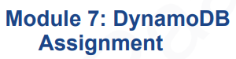

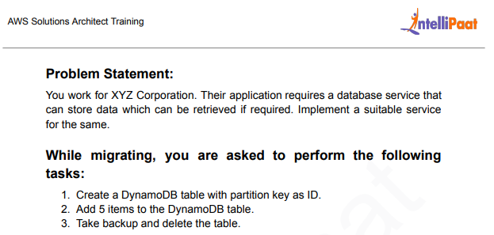

SOL:

1) Login to AWS Console and search for DynamoDB and click on create table.

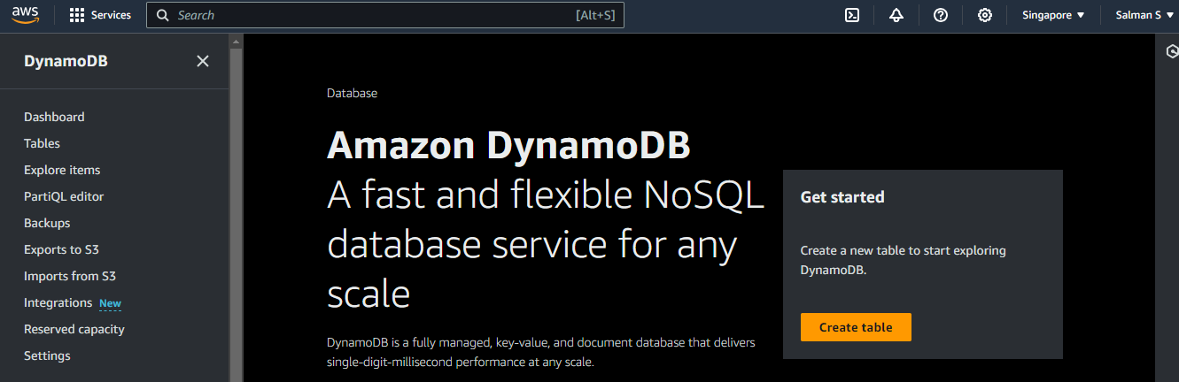

2) Name of the table we given is “test_table”

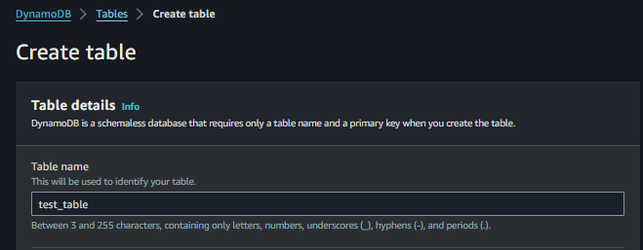

3) Partition key is “ID”

Partition key should be unique and cannot be duplicated but if we need duplicated partition key then we need to use sort key but for this assignment we will not use sort key so our partition key is unique.

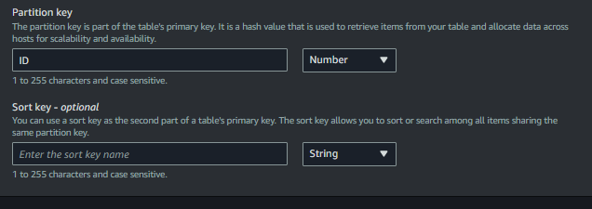

4) Table settings: We are going with Default table settings For this assignment and not with customize settings, we are going with 5RCU (Read capacity unit)& 5WCU (Write capacity unit)

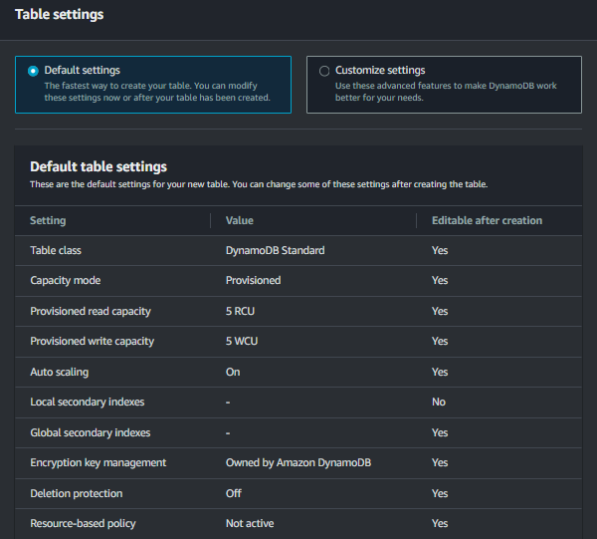

5)test_table created successfully

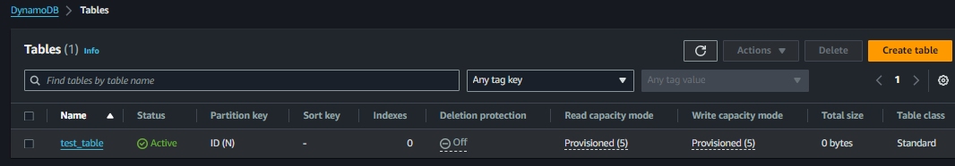

1. now go to explore items and select your database and click on create item.

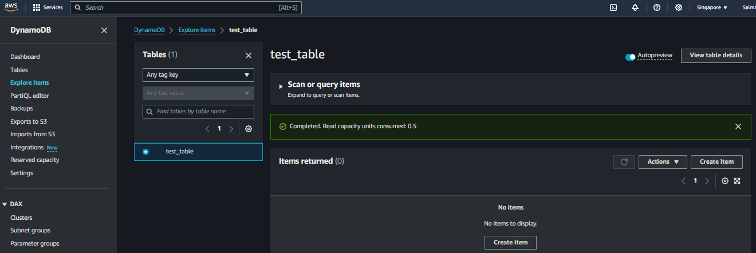

1. Adding Items to DynamoDB table

Mention the unique ID and add new another attribute “String” and updated the name

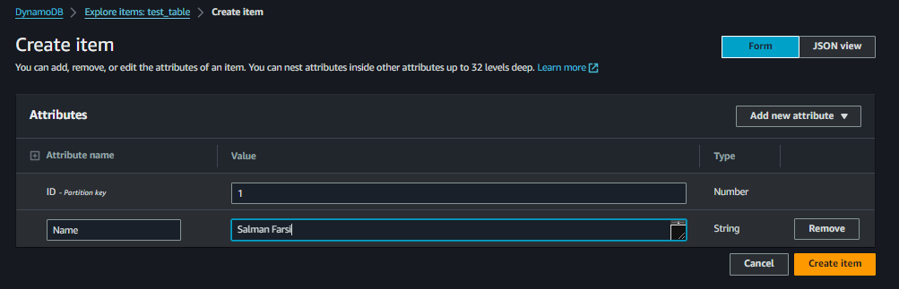

Added 2nd item using DynamoDB JSON View

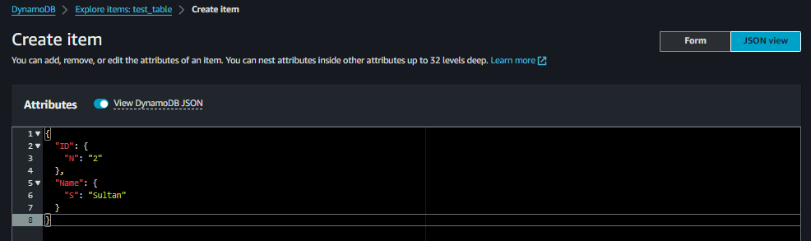

Added 3rd item using Normal JSON View

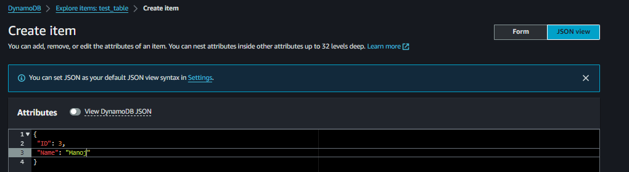

Added 4th item using form choose attribute as “Map” and added house number and street address.

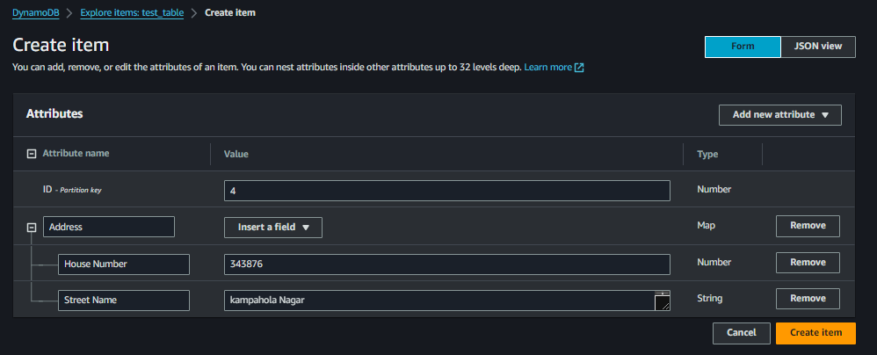

Added 5th item choose attribute “Number” and only added House Number

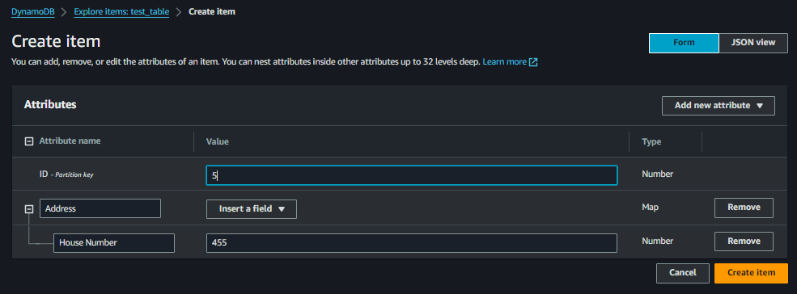

According to below screenshots 3 items contain id number and Name, 4th item contact id number and house number and 5th item contain the id number, House number & Street address

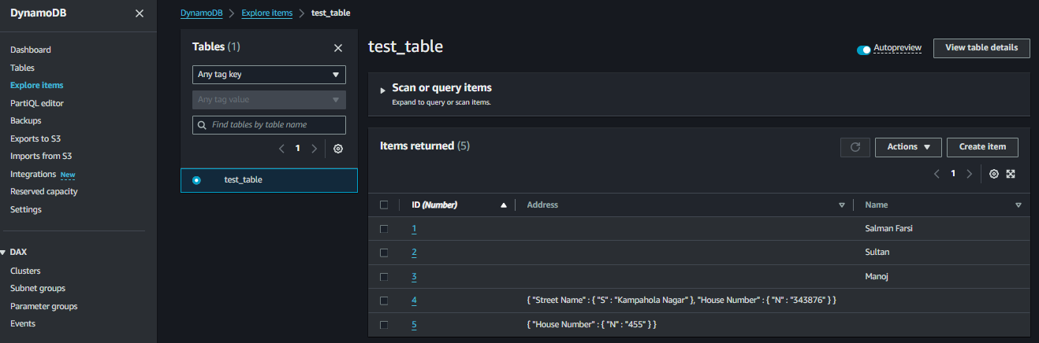

1. now click on Backup option to take the backup of your table and click on create backup

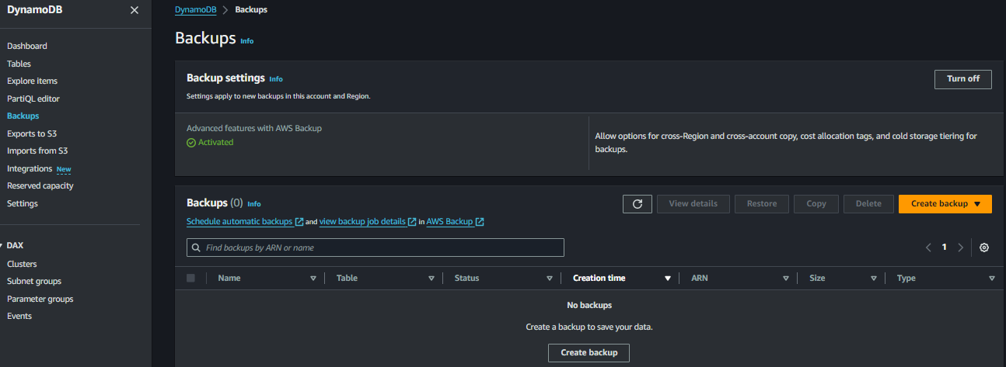

1. Select the table which you want to backup and click on create backup so in source table select the “test_table” and click on create backup

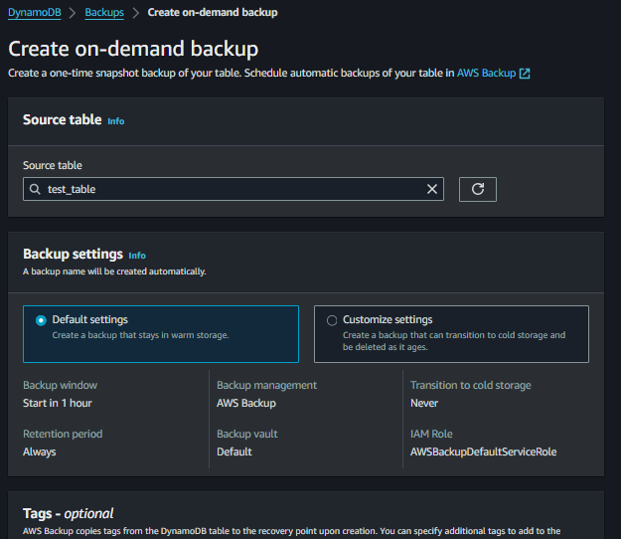

1. Backup will be stored in the AWS Backup service and we can check the details in the backup job details

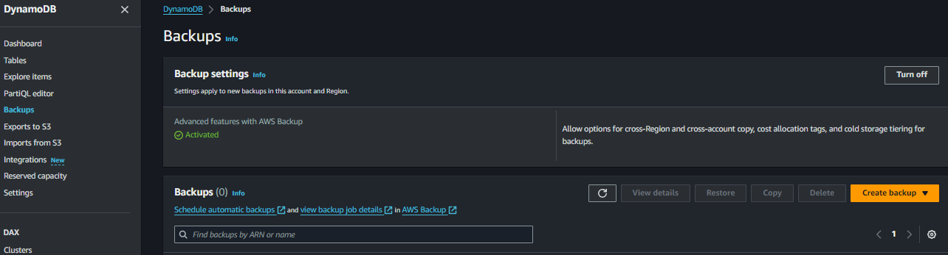

1. Backup of our table completed successfully as per below screenshots.

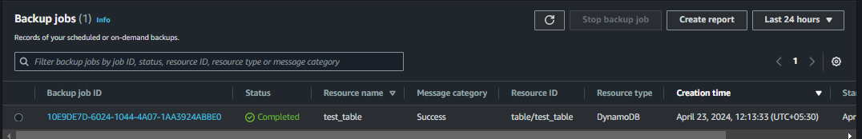

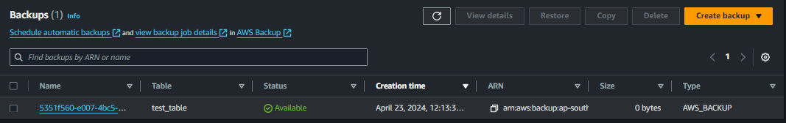

1. now we will going to delete our backup

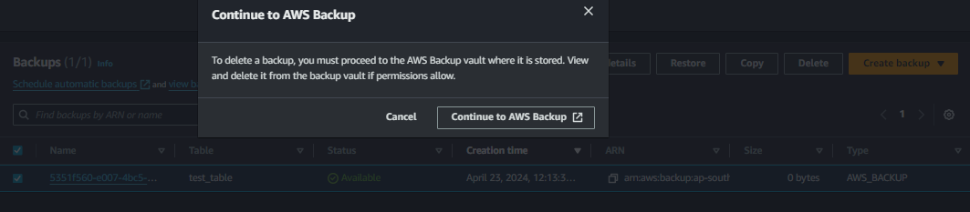

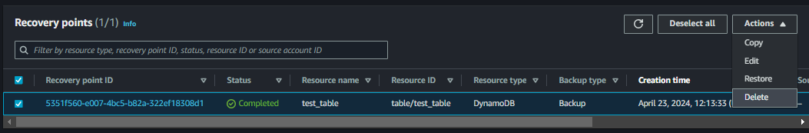

Deleted Successfully

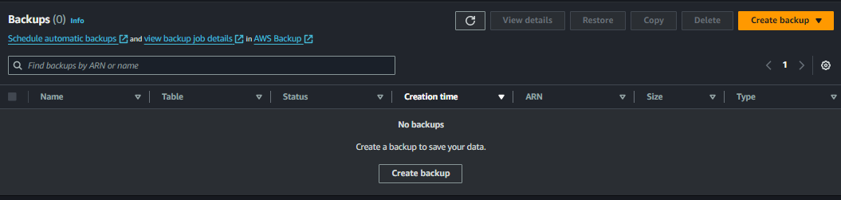

1. we will be going to delete our table

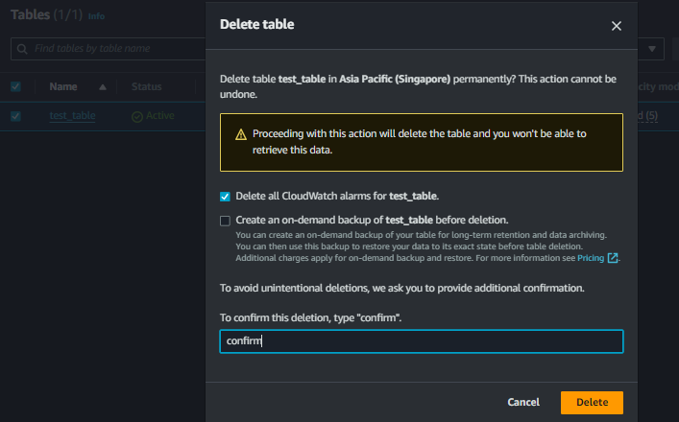

& it will be deleted successfully.

